Name: Per.____
Analysis of the Economies of the 13 Colonies

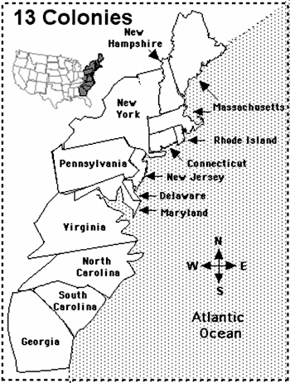
Geographical Context: Label the three colonial regions on this map, using the information in the table below.

Northern Colonies:  - Massachusetts  - Rhode Island  - Connecticut  - New Hampshire | Middle Colonies:  - New York  - New Jersey  - Pennsylvania  - Delaware | Southern Colonies:  - Maryland  - Virginia  - North Carolina  - South Carolina  - Georgia

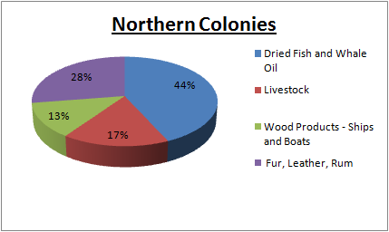

Fig 1a: Northern Colonies / New England had a short growing season and rocky soil; this was not ideal for growing and exporting cash crops (something that is grown and harvested for the sole purpose of selling it to make a profit - not for the consumption of the farmer). Colonists took advantage of other opportunities in the region, especially fishing and whaling in the bays, inlets, rivers and oceans that dominated their lands. The building and manufacturing of ships to support the fishing industry became a major part of the economy of the Northern economy. Northern colonists also built small factories that would support the processing and manufacturing of fish and whale oil. Also, many Northern Colonies turned to the manufacturing of sugar from the Caribbean into rum, as well as fur / leathers goods from the natural wildlife of the Northern Colonies or Canadian traders; all of which could be exported to Europe for a profit.

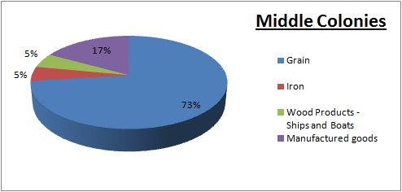

Fig 1b: The longer growing season of the Middle Colonies, more even land and less rock soil, in combination with milder winters (as compared to the Northern Colonies) allowed farmers to grow and cultivate fields of various grains. Grains were the cash crop that earned the Middle Colonies the nickname of the “breadbasket colonies”, as among the three colonial regions, they grew the highest percentage of grains. Further supporting the economy of the middle colonies was the manufacturing of goods in industrial centers such as New York City and Philadelphia.

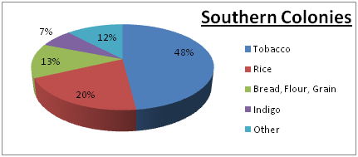

Fig 1c: Southern Colonies had a nearly year-round growing season as a result of warmer winters and humid summers allowing them to grow tobacco and rice, both of which thrive in warmer, more humid, climates. Tobacco and rice were the most profitable exports of all the cash crops grown in the 13 colonies between 1768 and 1777. Of their sum total of exports, nearly 88% of all Southern Colonies exports were agricultural (tobacco, rice, grains, and indigo).
Analysis Questions

- According to figures 1a, 1b, and 1c, how does the environment and geography impact the ability of colonies to produce cash crops?

- Which region had the highest percentage of economic activity devoted to shipbuilding? How did the geography and environment of this region contribute to or support the ability of this region to develop economic practices around shipbuilding?

- Which colonial region’s exports were mostly made up of grains? What percentage of their exports were grains? Why was their environment suitable for growing grains in comparison to the other two regions?

- Which region was able to export the two most profitable cash crops? Why was the environment of that region suitable for exporting those cash crops?

- Which region had the highest percentage of exports that were agricultural in nature? Keeping in mind that this region has a high percentage of agricultural exports, which word do you think would best describe this region: rural or urban? Why?

- Which region had the highest percentage of exports that were manufactured goods?

